**Plan and track work**

**Azure Boards | Azure DevOps Server 2020 | Azure DevOps Server 2019 | TFS 2018 - TFS 2013**

You track your work by creating work items. This article walks you through creating issues and tasks using a Kanban board for the Basic process, or creating user stories and tasks using for the Agile process.

Choose one of the following four system processes—**Agile**, **Basic**, **Scrum**, or **Capability Maturity Model Integration (CMMI)**—for guidance depending on what process was selected for your project. For an overview of each of these processes, see [Choose a process](https://docs.microsoft.com/en-us/azure/devops/boards/work-items/guidance/choose-process?view=azure-devops).

* [Agile process](https://docs.microsoft.com/en-us/azure/devops/boards/get-started/plan-track-work?view=azure-devops&tabs=scrum-process#tabpanel_1_agile-process)
* [Basic process](https://docs.microsoft.com/en-us/azure/devops/boards/get-started/plan-track-work?view=azure-devops&tabs=scrum-process#tabpanel_1_basic-process)
* [Scrum process](https://docs.microsoft.com/en-us/azure/devops/boards/get-started/plan-track-work?view=azure-devops&tabs=scrum-process#tabpanel_1_scrum-process)
* [CMMI process](https://docs.microsoft.com/en-us/azure/devops/boards/get-started/plan-track-work?view=azure-devops&tabs=scrum-process#tabpanel_1_cmmi-process)

The Scrum process provides several work item types—for example, product backlog items, tasks, bugs, features, and epics among others—to plan and track work. We recommend you start by adding product backlog items. If you need to group them into a hierarchy, you can define features. If you want to track additional details of work, you can add tasks child items to a product backlog item.

Within each work item form, you can describe the work to be done, assign work to project contributors, track status, and collaborate with others through the Discussion section.

Here we show how to add product backlog items and child tasks from the web portal and add details to those work items.

**Prerequisites**

* After you connect to a project, you can add work items. If you don't have a project yet, [create one in Azure DevOps](https://docs.microsoft.com/en-us/azure/devops/boards/get-started/sign-up-invite-teammates?view=azure-devops).
* To add work items to a board, and use all other board features, you must be granted **Basic** access and have been added as a member of the Contributors or Project Administrators group.
* If you have been granted **Stakeholder** access for a private project and have been added as a member of the Contributors or Project Administrators group, you can view boards, open and modify work items, and add child tasks to a checklist. However, you can't reorder or reparent a backlog item using drag-and-drop, nor update a field on a card.
* If you have been granted **Stakeholder** access for a public project, and have been added as a member of the Contributors or Project Administrators group, you have full access to all Boards features.

For details, see [Default permissions and access for Azure Boards](https://docs.microsoft.com/en-us/azure/devops/boards/get-started/permissions-access-boards?view=azure-devops)

**Open the Kanban board**

A Kanban board is provisioned with the addition of each project and each team. You can only create or add Kanban boards to a project by adding another team. To learn more, see [About teams and Agile tools](https://docs.microsoft.com/en-us/azure/devops/organizations/settings/about-teams-and-settings?view=azure-devops).

* [Agile process](https://docs.microsoft.com/en-us/azure/devops/boards/get-started/plan-track-work?view=azure-devops&tabs=scrum-process#tabpanel_2_agile-process)
* [Basic process](https://docs.microsoft.com/en-us/azure/devops/boards/get-started/plan-track-work?view=azure-devops&tabs=scrum-process#tabpanel_2_basic-process)
* [Scrum process](https://docs.microsoft.com/en-us/azure/devops/boards/get-started/plan-track-work?view=azure-devops&tabs=scrum-process#tabpanel_2_scrum-process)
* [CMMI process](https://docs.microsoft.com/en-us/azure/devops/boards/get-started/plan-track-work?view=azure-devops&tabs=scrum-process#tabpanel_2_cmmi-process)

The Backlog items Kanban board is the best tool for quickly adding product backlog items and child tasks. To open, choose **Boards>Boards**.

The Features Kanban board is the best tool for quickly adding features and product backlog items that are children of those features. To open the Features board from the Backlog items board, choose **Features** from the board selector.

The default Scrum process configuration doesn't enable the Epic backlog level for a team. To enable it, see [Select backlog navigation levels for your team](https://docs.microsoft.com/en-us/azure/devops/organizations/settings/select-backlog-navigation-levels?view=azure-devops).

**Add work items to your board**

* [Agile process](https://docs.microsoft.com/en-us/azure/devops/boards/get-started/plan-track-work?view=azure-devops&tabs=scrum-process#tabpanel_3_agile-process)
* [Basic process](https://docs.microsoft.com/en-us/azure/devops/boards/get-started/plan-track-work?view=azure-devops&tabs=scrum-process#tabpanel_3_basic-process)
* [Scrum process](https://docs.microsoft.com/en-us/azure/devops/boards/get-started/plan-track-work?view=azure-devops&tabs=scrum-process#tabpanel_3_scrum-process)
* [CMMI process](https://docs.microsoft.com/en-us/azure/devops/boards/get-started/plan-track-work?view=azure-devops&tabs=scrum-process#tabpanel_3_cmmi-process)

1. From the Backlog items board, choose **New item** and start adding those stories you want to track.
2. Enter return and the system assigns a work item ID to the user story.
3. To track the work you want to manage, add as many backlog items that you need.

**Add details to a board item**

Choose the issue or user story title to open it. Change one or more field values, add a description, or make a note in the **Discussion** section. You can also choose the  **Attachments** tab and drag-and-drop a file to share the file with others.

* [Agile process](https://docs.microsoft.com/en-us/azure/devops/boards/get-started/plan-track-work?view=azure-devops&tabs=scrum-process#tabpanel_4_agile-process)
* [Basic process](https://docs.microsoft.com/en-us/azure/devops/boards/get-started/plan-track-work?view=azure-devops&tabs=scrum-process#tabpanel_4_basic-process)
* [Scrum process](https://docs.microsoft.com/en-us/azure/devops/boards/get-started/plan-track-work?view=azure-devops&tabs=scrum-process#tabpanel_4_scrum-process)
* [CMMI process](https://docs.microsoft.com/en-us/azure/devops/boards/get-started/plan-track-work?view=azure-devops&tabs=scrum-process#tabpanel_4_cmmi-process)

For example, here we assign the product backlog item to Christie Church and set an Effort level of 8.

Choose **Save & Close** when done.

**Field descriptions**

**Field**

**Usage**

[Title](https://docs.microsoft.com/en-us/azure/devops/boards/queries/titles-ids-descriptions?view=azure-devops)

Enter a description of 255 characters or less. You can always modify the title later.

[Assigned To](https://docs.microsoft.com/en-us/azure/devops/boards/queries/query-by-workflow-changes?view=azure-devops)

Assign the work item to the team member responsible for performing the work. Depending on the context you are working in, the drop-down menu lists only team members or contributors to the project.

**Note**

You can only assign work to a single user. If you need to assign work to more than one user, add a work item for each user and distinguish the work to be done by title and description. The Assigned To field only accepts user accounts that have been **[added to a project or team](https://docs.microsoft.com/en-us/azure/devops/organizations/security/add-users-team-project?view=azure-devops)**.

[State](https://docs.microsoft.com/en-us/azure/devops/boards/queries/query-by-workflow-changes?view=azure-devops)

When the work item is created, the State defaults to the first state in the workflow. As work progresses, update it to reflect the current status.

[Reason](https://docs.microsoft.com/en-us/azure/devops/boards/queries/query-by-workflow-changes?view=azure-devops)

Use the default first. Update it when you change state as need. Each State is associated with a default reason.

[Area (Path)](https://docs.microsoft.com/en-us/azure/devops/boards/queries/query-by-area-iteration-path?view=azure-devops)

Choose the area path associated with the product or team, or leave blank until assigned during a planning meeting. To change the dropdown list of areas, see [Define area paths and assign to a team](https://docs.microsoft.com/en-us/azure/devops/organizations/settings/set-area-paths?view=azure-devops).

[Iteration (Path)](https://docs.microsoft.com/en-us/azure/devops/boards/queries/query-by-workflow-changes?view=azure-devops)

Choose the sprint or iteration in which the work is to be completed, or leave it blank and assign it later during a planning meeting. To change the drop-down list of iterations, see [Define iteration paths and configure team iterations](https://docs.microsoft.com/en-us/azure/devops/organizations/settings/set-iteration-paths-sprints?view=azure-devops).

[Description](https://docs.microsoft.com/en-us/azure/devops/boards/queries/titles-ids-descriptions?view=azure-devops)

Provide enough detail to create shared understanding of scope and support estimation efforts. Focus on the user, what they want to accomplish, and why. Don't describe how to develop the product. Do provide sufficient details so that your team can write tasks and test cases to implement the item.

[Acceptance Criteria](https://docs.microsoft.com/en-us/azure/devops/boards/queries/titles-ids-descriptions?view=azure-devops)

Provide the criteria to be met before the work item can be closed. Define what "Done" means by describing the criteria for the team to use to verify whether the backlog item or bug fix is fully implemented. Before work begins, describe the [criteria for customer acceptance](https://docs.microsoft.com/en-us/azure/devops/boards/backlogs/best-practices-product-backlog?view=azure-devops" \l "acceptance) as clearly as possible. Have conversations between the team and customers to determine the acceptance criteria. These criteria help ensure a common understanding within the team to meet customers' expectations. Also, this information provides the basis for acceptance testing.

[Priority](https://docs.microsoft.com/en-us/azure/devops/boards/queries/planning-ranking-priorities?view=azure-devops)

A subjective rating of the issue or task it relates to the business. You can specify the following values:

* **1**: Product cannot ship without the successful resolution of the work item, and it should be addressed as soon as possible.
* **2**: Product cannot ship without the successful resolution of the work item, but it does not need to be addressed immediately.
* **3**: Resolution of the work item is optional based on resources, time, and risk.
* **4**: Resolution of the work item is not required.

[Value Area](https://docs.microsoft.com/en-us/azure/devops/boards/queries/planning-ranking-priorities?view=azure-devops)

A subjective rating of the issue or task it relates to the business. You can specify the following values:

* **Architectural**: Technical services to implement business features that deliver solution .
* **Business**: Services that fulfill customers or stakeholder needs that directly deliver customer value to support the business (Default).

[Effort, Story Points, Size](https://docs.microsoft.com/en-us/azure/devops/boards/queries/query-numeric?view=azure-devops)

Provide a relative estimate of the amount of work required to complete an issue. Most Agile methods recommend that you set estimates for backlog items based on relative size of work. Such methods include powers of 2 (1, 2, 4, 8) and the Fibonacci sequence (1, 2, 3, 5, 8, etc.). Use any numeric unit of measurement your team prefers.  
The estimates you set are used to calculate [team velocity](https://docs.microsoft.com/en-us/azure/devops/report/dashboards/team-velocity?view=azure-devops) and [forecast sprints](https://docs.microsoft.com/en-us/azure/devops/boards/sprints/forecast?view=azure-devops).

**Update status**

The State field tracks the status of a work item. With the Kanban board, you can quickly update the status of backlog items by dragging and dropping them to a different column. This feature requires that you have Basic access or higher.

* [Agile process](https://docs.microsoft.com/en-us/azure/devops/boards/get-started/plan-track-work?view=azure-devops&tabs=scrum-process#tabpanel_5_agile-process)
* [Basic process](https://docs.microsoft.com/en-us/azure/devops/boards/get-started/plan-track-work?view=azure-devops&tabs=scrum-process#tabpanel_5_basic-process)
* [Scrum process](https://docs.microsoft.com/en-us/azure/devops/boards/get-started/plan-track-work?view=azure-devops&tabs=scrum-process#tabpanel_5_scrum-process)
* [CMMI process](https://docs.microsoft.com/en-us/azure/devops/boards/get-started/plan-track-work?view=azure-devops&tabs=scrum-process#tabpanel_5_cmmi-process)

Once a backlog item is approved to start work, drag the backlog item card from the **New** column to the **Approved** column. When work actually starts, drag the card to the **Committed** column. Once work has completed, move to the **Done** column.

**Tip**

You can add or rename columns as needed, see **[Customize your board](https://docs.microsoft.com/en-us/azure/devops/boards/get-started/customize-boards?view=azure-devops)**.

**Add tasks**

Task checklists provide a quick and easy way to track elements of work which are important to support completing a backlog item. In addition, you can assign individual tasks to different team members.

**Tip**

Tasks that you create from the Kanban board are automatically assigned to the sprint/iteration path of the parent work item under which you define them.

Tasks that you create from the Kanban board show up on your sprint taskboard. Also, tasks that you create from the [sprint backlog](https://docs.microsoft.com/en-us/azure/devops/boards/sprints/assign-work-sprint?view=azure-devops) or [taskboard](https://docs.microsoft.com/en-us/azure/devops/boards/sprints/task-board?view=azure-devops) show up within tasks checklists on the Kanban board.

* [Agile process](https://docs.microsoft.com/en-us/azure/devops/boards/get-started/plan-track-work?view=azure-devops&tabs=scrum-process#tabpanel_6_agile-process)
* [Basic process](https://docs.microsoft.com/en-us/azure/devops/boards/get-started/plan-track-work?view=azure-devops&tabs=scrum-process#tabpanel_6_basic-process)
* [Scrum process](https://docs.microsoft.com/en-us/azure/devops/boards/get-started/plan-track-work?view=azure-devops&tabs=scrum-process#tabpanel_6_scrum-process)
* [CMMI process](https://docs.microsoft.com/en-us/azure/devops/boards/get-started/plan-track-work?view=azure-devops&tabs=scrum-process#tabpanel_6_cmmi-process)

1. To start adding tasks, choose the  actions icon for the story and select the  **Add Task** option.

Enter a title for the task and type Enter when done.

1. If you have a number of tasks to add, simply keep typing your task titles and type Enter.
2. You can mark a task as done, expand or collapse the task checklist, or reorder and reparent tasks.

| **TABLE 7** | | |
| --- | --- | --- |
| **Mark a task as done** | **Reorder and reparent tasks** | **Expand or collapse the checklist** |
| To mark a task as complete, check the task checkbox. The task State changes to **Done**. | To reorder a task, drag it within the checklist. To reparent a the task, drag it to another issue on the board. | To expand or collapse a task checklist, simply choose the task annotation. |

**Add details to a task**

If you have details you want to add about a task, choose the title, to open it. Change one or more field values, add a description, or make a note in the **Discussion** section. Choose **Save & Close** when done.

* [Agile process](https://docs.microsoft.com/en-us/azure/devops/boards/get-started/plan-track-work?view=azure-devops&tabs=scrum-process#tabpanel_7_agile-process)
* [Basic process](https://docs.microsoft.com/en-us/azure/devops/boards/get-started/plan-track-work?view=azure-devops&tabs=scrum-process#tabpanel_7_basic-process)
* [Scrum process](https://docs.microsoft.com/en-us/azure/devops/boards/get-started/plan-track-work?view=azure-devops&tabs=scrum-process#tabpanel_7_scrum-process)
* [CMMI process](https://docs.microsoft.com/en-us/azure/devops/boards/get-started/plan-track-work?view=azure-devops&tabs=scrum-process#tabpanel_7_cmmi-process)

Here we assign the task to Jamal.

**Field descriptions**

In addition to the fields you can define for a backlog item—user story, issue, product backlog item, or requirement—you can specify the following fields for a task to support capacity and time tracking.

**Note**

There are no inherent time units associated with this field even though the taskboard always shows "h" for hours in relationship to Remaining Work. You can specify work in any unit of measurement your team chooses.

**Field**

**Usage**

[Activity](https://docs.microsoft.com/en-us/azure/devops/boards/queries/query-numeric?view=azure-devops)

The type of activity that is required to perform a task.To learn more about how this field is used, see [Capacity planning](https://docs.microsoft.com/en-us/azure/devops/boards/sprints/set-capacity?view=azure-devops). Allowed values are:

* **Deployment**
* **Design**
* **Development**
* **Documentation**
* **Requirements**
* **Testing**

[Discipline](https://docs.microsoft.com/en-us/azure/devops/boards/queries/query-numeric?view=azure-devops) (CMMI process)

The type of activity that is required to perform a task.To learn more about how this field is used, see [Capacity planning](https://docs.microsoft.com/en-us/azure/devops/boards/sprints/set-capacity?view=azure-devops). Allowed values are:

* **Analysis**
* **Development**
* **Test**
* **User Education**
* **User Experience**

[Original Estimate](https://docs.microsoft.com/en-us/azure/devops/boards/queries/query-numeric?view=azure-devops)

The amount of estimated work required to complete a task. Typically, this field doesn't change after it is assigned.

[Remaining Work](https://docs.microsoft.com/en-us/azure/devops/boards/queries/query-numeric?view=azure-devops)

The amount of work that remains to finish a task. You can specify work in hours or in days. As work progresses, update this field. It's used to calculate [capacity charts](https://docs.microsoft.com/en-us/azure/devops/boards/sprints/set-capacity?view=azure-devops) and the [sprint burndown chart](https://docs.microsoft.com/en-us/azure/devops/report/dashboards/configure-sprint-burndown?view=azure-devops).  
If you divide a task into subtasks, specify Remaining Work for the subtasks only.

[Completed Work](https://docs.microsoft.com/en-us/azure/devops/boards/queries/query-numeric?view=azure-devops)

The amount of work spent implementing a task. Enter a value for this field when you complete the task.

[Task Type](https://docs.microsoft.com/en-us/azure/devops/boards/work-items/guidance/cmmi/guidance-requirements-field-reference-cmmi?view=azure-devops) (CMMI only)

Select the kind of task to implement from the allowed values:

* **Corrective Action**
* **Mitigation Action**
* **Planned**

**Capture comments in the Discussion section**

Use the **Discussion** section to add and review comments made about the work being performed.

The rich text editor tool bar displays below the text entry area when you click your cursor within each text box that can be formatted.

**Note**

There is no Discussion work item field. To query work items with comments entered in the Discussion area, you filter on the **[History field](https://docs.microsoft.com/en-us/azure/devops/boards/queries/history-and-auditing?view=azure-devops)**. The full content of the text entered into the Discussion text box is added to the History field.

**Mention someone, a group, work item, or pull request ( ,  , or )**

Choose one of these icons — ,  , or — to open a menu of recent entries you've made to mention someone, link to a work item, or link to a pull request. Or, you can simply type **@**, **#**, or **!** to open the same menu.

Type a name, or enter a number and the menu list will filter to match your entry. Choose the entry you want to add. You can bring a group into the discussion by typing **@** and the group name, such as a team or security group.

**Edit or delete a comment**

If you need to edit or delete any of your discussion comments, choose  **Edit** or choose the  actions icon and then choose **Delete**.

After updating the comment, choose **Update**. To delete the comment, you'll need to confirm that you want to delete it.

A full audit trail of all edited and deleted comments is maintained in the **History** tab on the work item form.

**Add a reaction to a comment**

You can add one or more reactions to any comment. Choose a smiley icon at the upper-right corner of any comment or choose from the icons at the bottom of a comment next to any existing reactions. To remove your reaction, click the reaction on the bottom of your comment. The following shows an example of the experience of adding a reaction, as well as the display of reactions on a comment.

For more information, check this out:

<https://docs.microsoft.com/en-us/azure/devops/boards/get-started/plan-track-work?view=azure-devops&tabs=scrum-process>

**Customize your boards**

**Azure Boards | Azure DevOps Server 2020 | Azure DevOps Server 2019 | TFS 2018 - TFS 2013**

This article shows how to customize a Kanban board. You have one Kanban board for each active product or portfolio backlog.

You can configure your Kanban board in several ways to support specific tracking needs. For example:

* Update fields directly from the card
* Highlight cards based on field assignments
* Add columns to track other workflow states
* Add swimlanes to expedite work or differentiate work assigned to different service classes.

**Open Settings for the board**

* [Basic process](https://docs.microsoft.com/en-us/azure/devops/boards/get-started/customize-boards?view=azure-devops&tabs=basic-process#tabpanel_1_basic-process)
* [Agile process](https://docs.microsoft.com/en-us/azure/devops/boards/get-started/customize-boards?view=azure-devops&tabs=basic-process#tabpanel_1_agile-process)

Each team can customize their Issues and Epics boards and sprint Taskboards.

1. [Open your Kanban board](https://docs.microsoft.com/en-us/azure/devops/boards/get-started/plan-track-work?view=azure-devops).
2. Choose the  gear icon to configure the board setting settings.

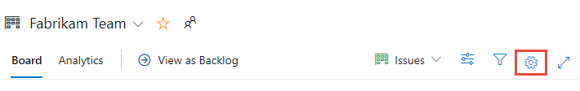

The Settings dialog opens.

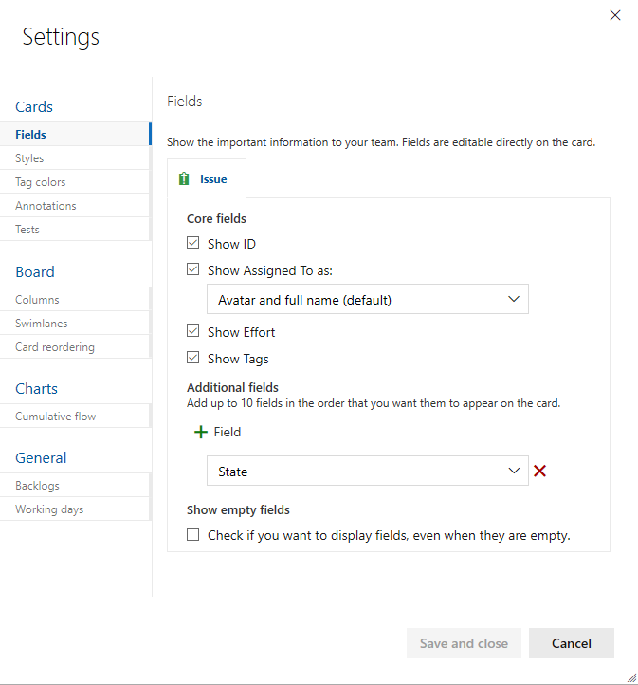

1. Choose one of the following tabs based on what you want to customize:

**Common customizations:**

* + **Fields**: Set what fields appear on cards.
  + **Columns**: Add, rename, and configure columns for the board.
  + **Swimlanes**: Add swimlanes to a board to easily track high priority levels, distinguish different service classes, or track blocked items.
  + **Backlogs**: Enable or disable issues or epics from being tracked on backlogs and boards.

**Less common customizations:**

* + **Styles**: Specify the card color to display based on field criteria you specify.
  + **Tag colors**: Specify the tag color to display based on tag criteria you specify.
  + **Annotations**: Enable or disable task or test annotations.
  + **Tests**: Configure how you want tests to appear and behave on the cards.
  + **Card reordering**: Choose to enable/disable changing of the backlog priority when dragging and dropping cards on the board.
  + **Cumulative flow**: Set how you want the cumulative flow diagram to display.
  + **Working days**: Set the active weekdays to use when tracking capacity and burndown.

**Customize fields**

To quickly assign fields from the card without having to open the work item, add them to display on the card.

* [Basic process](https://docs.microsoft.com/en-us/azure/devops/boards/get-started/customize-boards?view=azure-devops&tabs=basic-process#tabpanel_2_basic-process)
* [Agile process](https://docs.microsoft.com/en-us/azure/devops/boards/get-started/customize-boards?view=azure-devops&tabs=basic-process#tabpanel_2_agile-process)

1. To configure the fields displayed on cards, choose the **Fields** tab.
2. Check or uncheck those fields you want to display or not display on the board.
3. To add a field, choose plus icon **Field** to add a field.

For example, here we uncheck **Show ID** and add the **Priority** field.

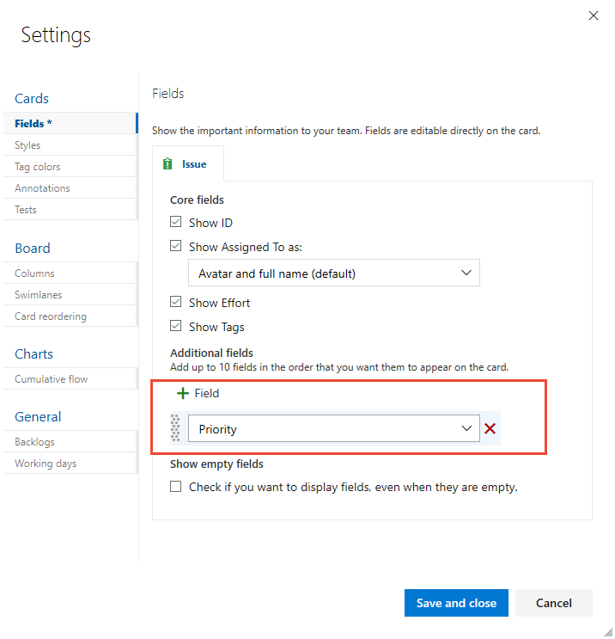

1. To remove a field, choose the  delete icon next to the field.
2. Choose **Save and close** when done. To learn more, see [Customize cards](https://docs.microsoft.com/en-us/azure/devops/boards/boards/customize-cards?view=azure-devops).

**Customize columns**

You can add columns or change column names.

* [Basic process](https://docs.microsoft.com/en-us/azure/devops/boards/get-started/customize-boards?view=azure-devops&tabs=basic-process#tabpanel_3_basic-process)
* [Agile process](https://docs.microsoft.com/en-us/azure/devops/boards/get-started/customize-boards?view=azure-devops&tabs=basic-process#tabpanel_3_agile-process)

1. To add a column or change column settings, choose **Columns** tab.

Here we choose plus icon **Column**, and then specify the name as **Research**.

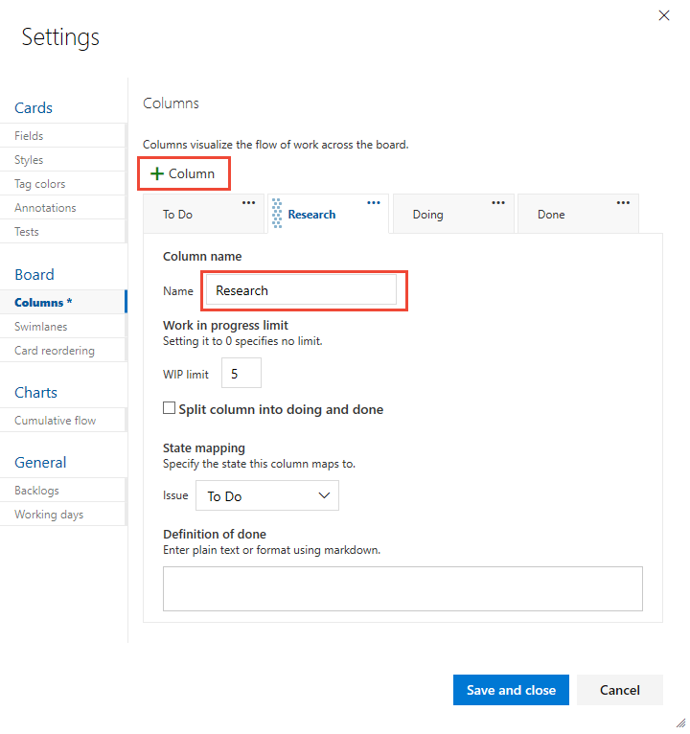

1. Choose **Save and close** when done. To learn more about column settings, see [Add columns to your Kanban board](https://docs.microsoft.com/en-us/azure/devops/boards/boards/add-columns?view=azure-devops).

**Customize swimlanes**

Swimlanes appear as rows within the Kanban board and provide yet another way to categorize work you want to track.

1. To add a swimlane, choose **Swimlanes** tab and choose plus icon **Swimlane**, and then specify the name.

Here we label the swimlane **Expedite**.

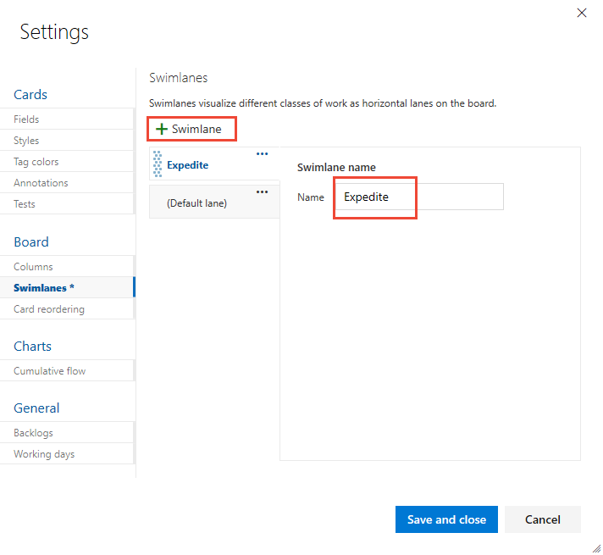

1. Choose **Save and close** when done. To learn more about working with swimlanes , see [Expedite work with swimlanes](https://docs.microsoft.com/en-us/azure/devops/boards/boards/expedite-work?view=azure-devops).

**Add or remove backlog levels**

* [Basic process](https://docs.microsoft.com/en-us/azure/devops/boards/get-started/customize-boards?view=azure-devops&tabs=basic-process#tabpanel_4_basic-process)
* [Agile process](https://docs.microsoft.com/en-us/azure/devops/boards/get-started/customize-boards?view=azure-devops&tabs=basic-process#tabpanel_4_agile-process)

If you decide you don't want to use Epics to track work, you can turn it off and it won't show up as a board or backlog. By default, it is enabled for new projects.

1. Choose **Backlogs** tab and uncheck the work item type you no longer want to track on backlogs and boards.

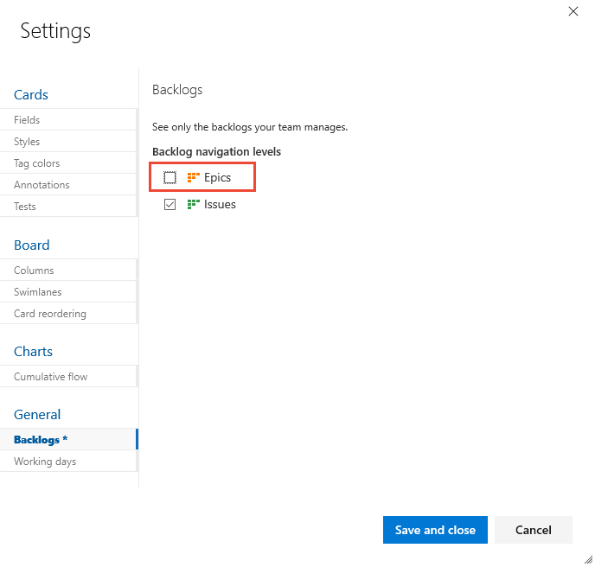

1. Choose **Save and close** when done.

**Note**

Contributors will still be able to create Epics from other views, they just won't be able to view Epics within a backlog or board. To completely disable the Epic work item type, see **[Add and manage work item types, Enable or disable a WIT](https://docs.microsoft.com/en-us/azure/devops/organizations/settings/work/customize-process-work-item-type?view=azure-devops" \l "enable-disable)**.

**Review your changes**

After you close the settings dialog, refresh (F5) your board to view your changes. Verify that all changes appear as expected, or revisit the Settings dialog to make a change.

* [Basic process](https://docs.microsoft.com/en-us/azure/devops/boards/get-started/customize-boards?view=azure-devops&tabs=basic-process#tabpanel_5_basic-process)
* [Agile process](https://docs.microsoft.com/en-us/azure/devops/boards/get-started/customize-boards?view=azure-devops&tabs=basic-process#tabpanel_5_agile-process)

Here we show the customizations made in this article. The following image also shows a style applied to the color when the Priority=1.

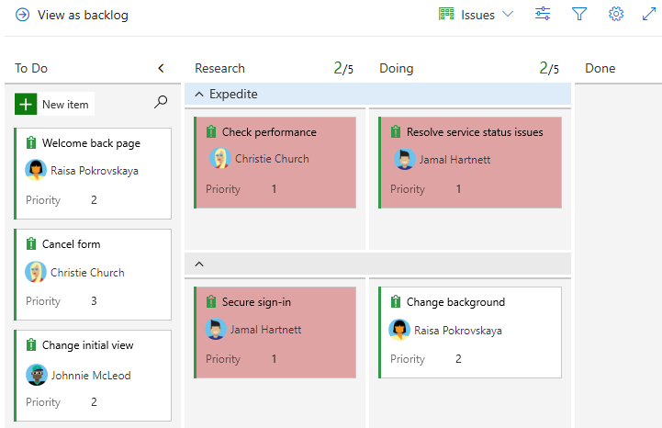

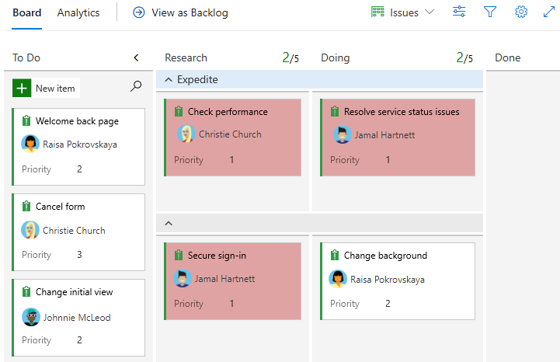

For more information, check this out:

<https://docs.microsoft.com/en-us/azure/devops/boards/get-started/plan-track-work?view=azure-devops&tabs=scrum-process>